**IBM COGNOS ACCOUNT**

|  |  |
| --- | --- |
| Team ID | PNT2022TMID06318 |
| Project Title | Retail Store Stock Inventory Analytics |

**SELVAMUTHUKUMAR A**

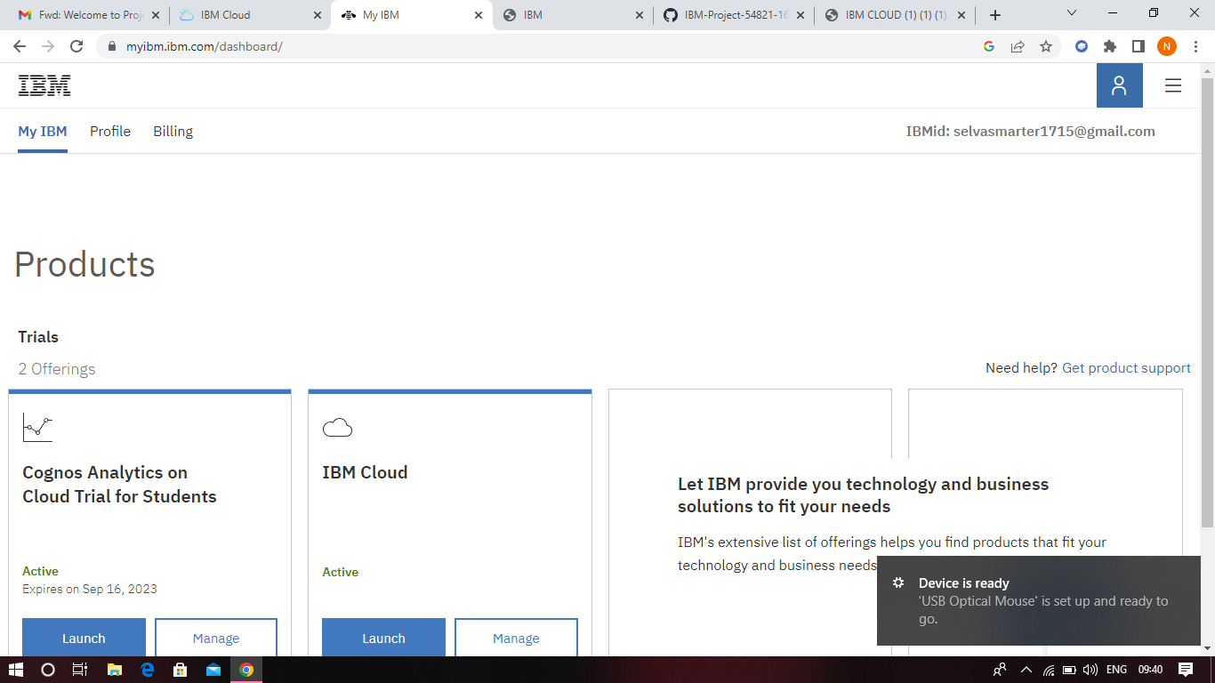

**KAVITHA N**

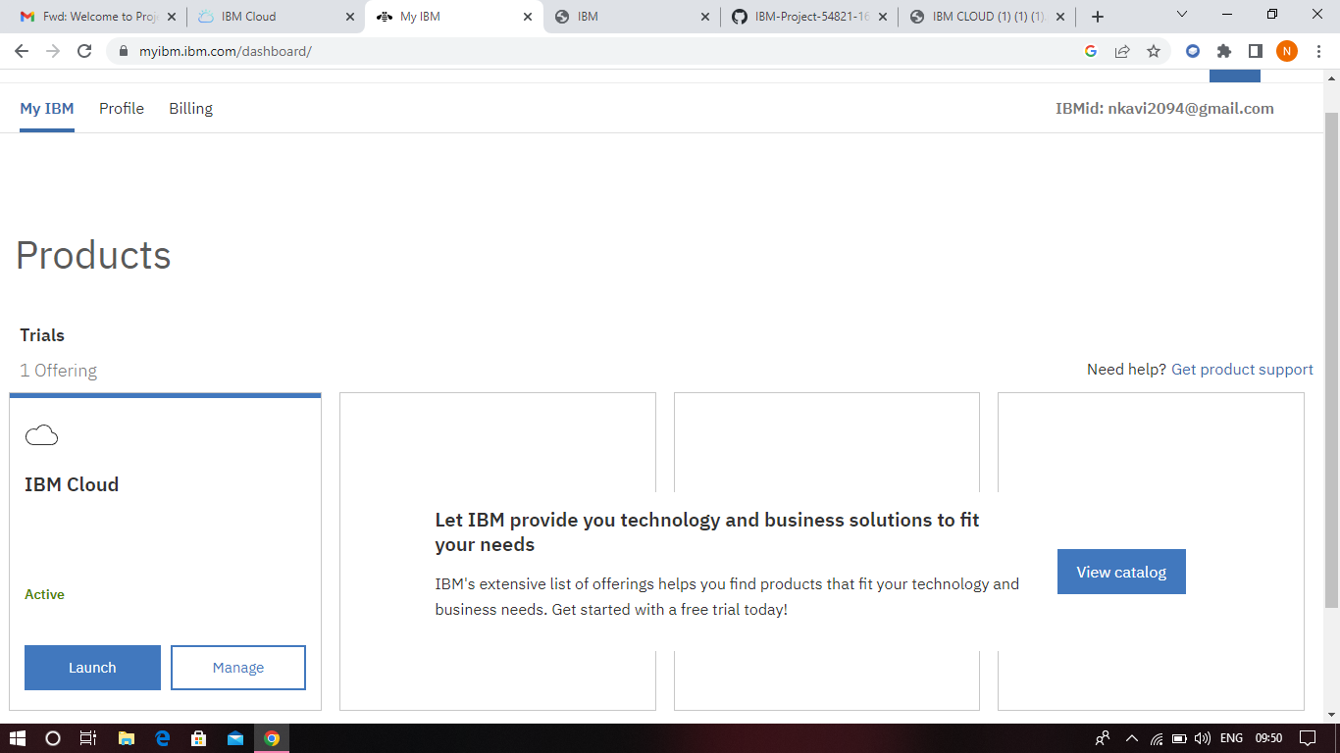

**HOLLY SHRUTHI V**

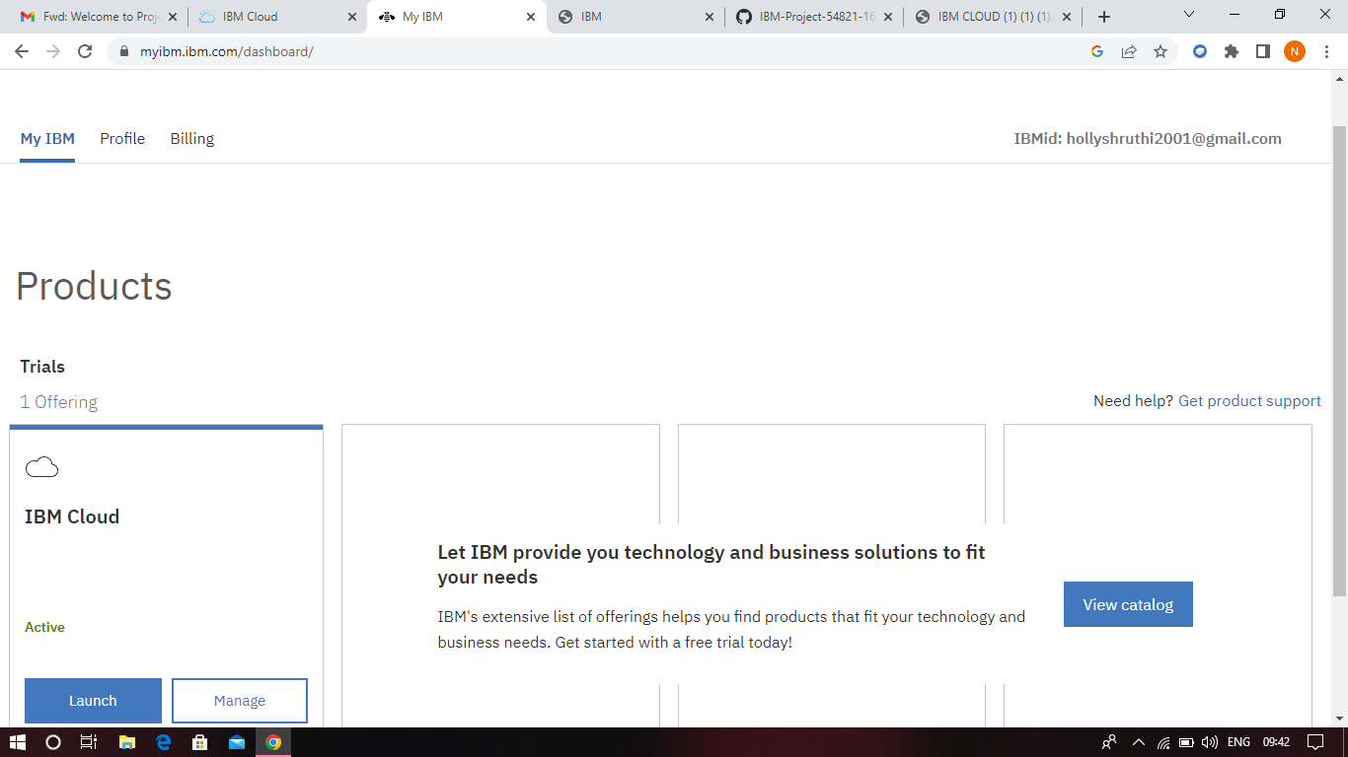

**NITHYASHREE V**

